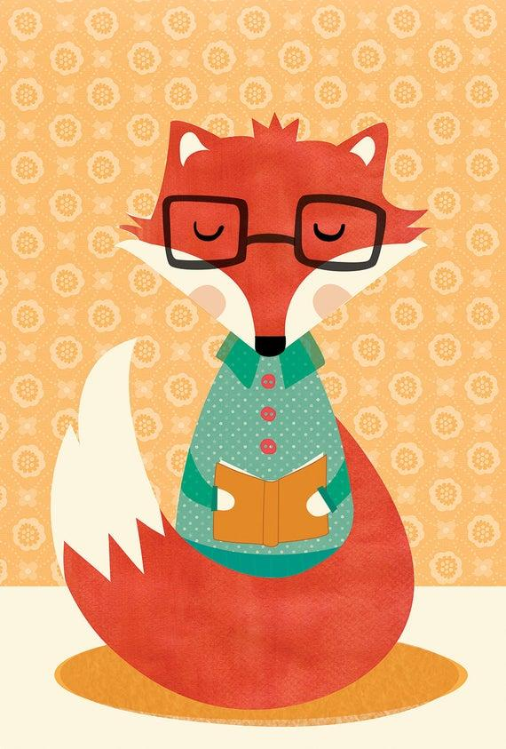 **Spartacus Reading Challenge** 

Please fill out and return when you are done with your book.

Every form will be entered into a **prize drawing.**

Student Name:

Book Title:

Star Rating (highlight): 1 (not great) 2 (just ok) 3 (good) 4 (read this!)

Show us that you read the book! Write two Kahoot! Questions about the book and four multiple choice answers for each.

**Question 1:**

Correct answer (a)

Wrong answers (b)

(c)

(d)

**Question 2:**

Correct answer (a)

Wrong answers (b)

(c)

(d)